|  |
| --- |
| **A**  **PROJECT REPORT ON** |
|  |
|  |
| Online Cloths Shopping System |
|  |
|  |
| SUBMITTED IN  PARTIAL FULFILLMENT OF  **DIPLOMA IN MOBLIE COMPUTING (PG-DMC)** |
|  |
|  |
|  |
|  |
|  |
|  |
|  |
| **BY**  **ABHISHEK GADDAM** |
|  |
|  |
| **UNDER THE GUIDENCE OF**  **MANJUSHA NIKAM** |
|  |
|  |
|  |
| **AT**  **SUNBEAM INSTITUTE OF INFORMATION TECHNOLOGY,**  **PUNE** |

|  |  |  |  |
| --- | --- | --- | --- |
| **SUNBEAM INSTITUTE OF INFORMATION TECHNOLOGY,**  **PUNE.** | | | |
|  | | | |
|  | | | |
|  | | | |
|  | | | |
| **CERTIFICATE** | | | |
|  | | | |
| This is to certify that the project | | | |
|  | | | |
| Online Cloths Shopping System | | | |
|  | | | |
| Has been submitted by | | | |
|  | | | |
| **ABHISHEK GADDAM** | | | |
|  | | | |
|  | | | |
| In partial fulfillment of the requirement for the Course of **PG Diploma in Mobile Computing (PG-DMC Mar 2023)** as prescribed by The **CDAC** ACTS, PUNE. | | | |
|  | | | |
|  | | | |
| Place: Pune | | | Date: 26-AUG-2023 |
|  | | | |
|  | | | |
|  | | | |
|  | | | |
|  | | | |
|  | | | **MANJUSHA NIKAM** |
|  | | | **Project Guide** |
|  |  |  |  |

**ACKNOWLEDGEMENT**

I would like to express my special thanks of gratitude to my teacher **MANJUSHA NIKAM** as well as our Director Nitin Khudale who gave me the golden opportunity to do this wonderful project on the topic User Analytics, which also helped me in doing a lot of Research and I came to know about so many new things I am really thankful to them.

ABHISHEK GADDAM

**ABSTRACT**

Multi-Platform Application that will track user’s daily life stats and let the user see how well he/she doing. Application will get data from sensor and user can also put data manually all this data is supposed to be synced with server and stored in data base. A website of same application will allow user to see details in very informatic manner

|  |  |  |
| --- | --- | --- |
|  | **INTRODUCTION** | 1 |
|  | 1.1 Introduction | 2 |
|  | **Product Overview and Summary** |  |
|  | 2.1 Purpose |  |
|  | 2.2 Scope |  |
|  | 2.3 User Classes and Characteristics |  |
|  | 2.4 Design and Implementation Constraints |  |
|  | **REQUIREMENTS** |  |
|  | 3.1 Functional Requirements |  |
|  | 3.1.1 Use case for Administrator. |  |
|  | 3.1.2 Use case for User. |  |
|  | 3.2 Non - Functional Requirements |  |
|  | 3.2.1 Usability Requirement |  |
|  | 3.2.2 Performance Requirement |  |
|  | 3.2.3 Reliability Requirement |  |
|  | 3.2.4 Portability Requirement |  |
|  | 3.2.5 Security Techniques |  |
|  | **PROJECT DESIGN** |  |
|  | 4.1 Data Model |  |
|  | 4.1.1 Database Design |  |
|  | 4.2 Process Model |  |
|  | 4.2.1 Functional Decomposition Diagram |  |
|  | 4.2.2 Data Flow Diagram (DFD) |  |
|  | **PROJECT RELATED STATISTICS** |  |
|  | **CONCLUSION** |  |

**INDEX**

**LIST OF TABLES**

|  |  |  |
| --- | --- | --- |
| **Section** | **Table Title** | **Page** |
| **Fig 3** | **Complete Database** |  |
|  |  |  |
|  |  |  |
|  |  |  |
|  |  |  |
|  |  |  |

**LIST OF FIGURES**

|  |  |  |
| --- | --- | --- |
| **Section** | **Figure Title** | **Page** |
| **Fig 1-2** | **User & Admin Use Case Diagram** |  |
| **Fig 3** | **Data Flow Diagram** |  |
| **Fig 4 -9** | **Dashboard Screen Shots** |  |
| **Fig 10-13** | **Mobile Application Screen Shots** |  |
|  |  |  |
|  |  |  |
|  |  |  |
|  |  |  |
|  |  |  |
|  |  |  |
|  |  |  |
|  |  |  |

**INTRODUCTION**

Currently, the online market is a large and promising platform for retail businesses. Meanwhile, consumers are trending towards "online shopping" to save time and effort. Therefore, retail businesses are increasingly venturing into this online market with the aim of improving efficiency and sales revenue.

It is known that traditional methods of selling have significant drawbacks when it comes to advertising products and tracking revenue. Revenue reporting is entirely dependent on Excel software, which leads to several challenging issues. Generating a report takes a long time and consumes a lot of time and resources. If there are errors in data entry, they may not be detected and corrected, such as attempting to sell a product that is not in stock or is out of stock without notifying the customer. Employees are also not prompted to restock certain items. Furthermore, customers cannot actively engage in pre-ordering and purchasing products from the shop; all sales and purchases must occur simultaneously between the buyer and the seller.

**The goal of this project:** Building an online store is indeed crucial for various reasons. It helps the store manage its inventory better, generate fast and accurate revenue reports, reduce labor, cut costs, and save time. Advertising products and the brand also become more straightforward. From the customer's perspective, an online shop saves them time while shopping and allows them to "reserve" their favorite products without worrying about them being sold out when they visit the store. Customers can also be proactive in browsing and placing orders.

Given the issues you've mentioned, your choice of the topic "Building a Fashion E-commerce Website" is well-suited to help fashion stores improve their inventory management and product advertising. It aligns with the current global development trends. This document will comprehensively describe such an application’s research, design, testing, and development.

**Product Overview and Summary**

**| Purpose:** building a fashion e-commerce website not only helps optimize store management but also provides a convenient and trustworthy shopping experience for customers.

* Ensuring that transactions between the store and customers take place quickly and accurately.
* Helps employees manage the store's operations, oversee categories, view reports, and statistics.
* Ensures customers have accurate information about products, can place orders, and make payments easily.

**| Scope**: Building a fashion e-commerce website can help ensure the following important factors:

* Swift and Accurate Transactions: Through an online interface, customers can easily browse products, add them to their shopping carts, and make payments without the need to visit a physical store. This ensures that transactions take place quickly and accurately.
* Store Management: The system can provide employees and store managers with information about inventory status, pending orders, and revenue reports in an easy-to-access manner. This helps them make better management decisions and optimize the store's operations.
* Accurate Product Information: Each product on the website can be presented with detailed information, high-quality images, and clear pricing. This helps customers have an accurate understanding of the product before making a purchase, ordering, and making payments conveniently through the website.
* Simplified Payments: The system can integrate various online payment methods, making it easy and secure for customers to complete their payments. This also ensures that payment information is processed accurately and securely.

**User Classes and Characteristics**:

* Since it is based on many platforms there are many classes and their usage but most importantly the app uses a Model for the user to be able to buy the product first they will put the product in the cart and actually have to do it login function when you want to checkout products
* Android platform as well as Reactjs has a Data persistence implementation. With the functionality of a good front-end. Both Android and Reactjs work well when retrieving data from the database access API.
* Regarding database management, the MySQL platform is sufficient for managing products and customers of the online sales system.

**| Design and Implementation Constraints**

**- User Interface**

To achieve the efficiency of the purchase process on the online sales system, using Reactjs and Android to create a very effective user interface. For Reactjs is a front-end known as Single Page Application which is very effective. The interface created from Reactij makes it more user-friendly. Besides, Android also creates a convenient interface that is not inferior to help users easily make effective shopping on handheld devices..

**- Multi-platform**: A web application product is created with many different platforms that make it highly effective when providing many tools to consumers. Consumers can make purchases right on both web browsers as well as on mobile devices. The purchase is served easily anytime, anywhere as long as the customer can connect to the internet.

**Functional Requirements**

**1. Admin** - The person with the highest responsibility for the system, has all the rights of the system including (user management, category management, message management, banner management, brand management, owner management).

**2. User** - Ordinary users, who have registered an account with the system, have the right to view order history, manage personal information, add products to the cart, manage personal addresses, comment on posts, rate products.

**3. User management** - User management function, allowing administrators to search, delete users, view .

**4. Catalog** - All categories management function allows administrator to search, add, edit, delete, view

**5. Order Management** - Order management function, allowing sales staff to search, view detailed information, update order status, export excel.

**6. Product Management** - All products management function allows administrator to search, add, edit, delete, view all products in the system.

**7. Personal Information** - Personal information management function allows members to edit and view their personal information in the system.

**8. View Order History** - Personal order management function allows members to review information about orders

**9. Add Product to Cart** - The function of adding products to the cart allows members to add products, update quantities, and delete products in the system's cart.

*10. View Product List* - Product information view function allows visitors to view full details of each product in the system.

**| Use Case for User**:

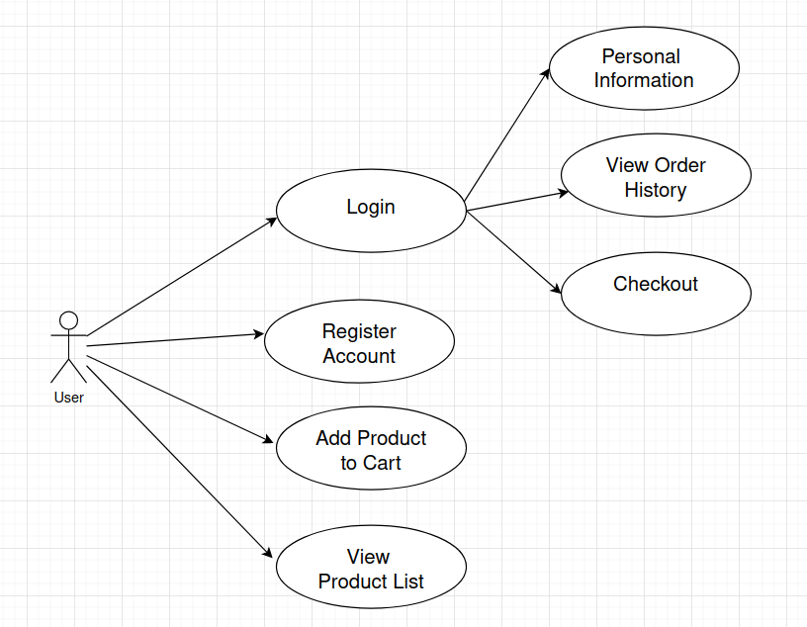

**| Use Case for Admin**:

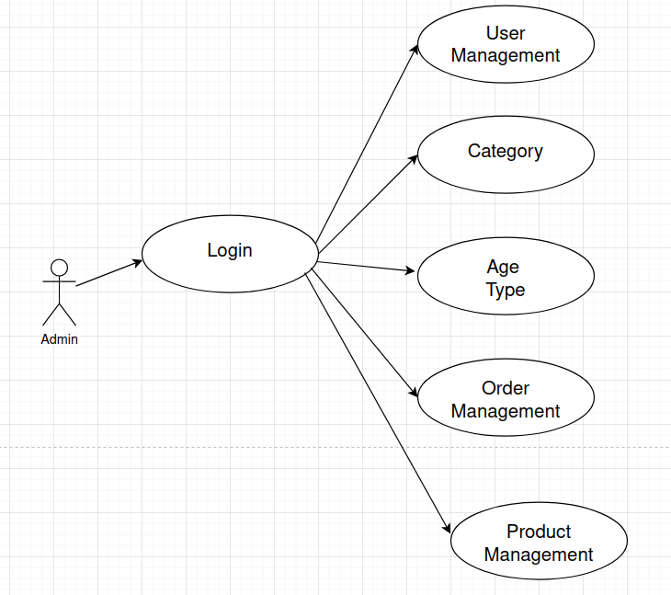

Fig. 2

**| API:**

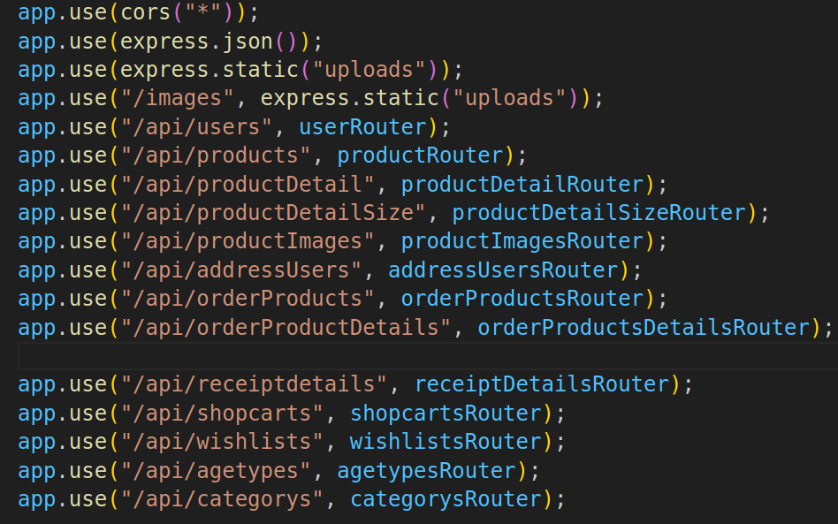

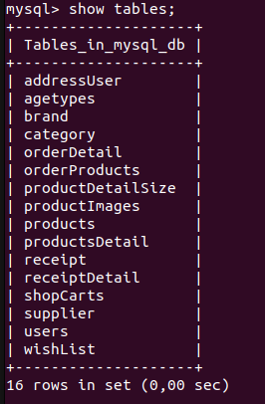**| Database:**

Fig. 1

**Non - Functional Requirements**

**Usability Requirement:** Application should be easy to use and provide basic user interface that can be used without any tutorial.

Multiple views must be used for modularity in this concept, I will be referring to the ease of use of a mobile application. The aim of the use of the mobile application is to get some features and functionality and the application would be difficult to use without the usability being considered. Every application is expected to be effective, sophisticated, and satisfactory and the color and contrast should be intact and follow some other principles that are considered the standard to be followed by developers. The design of the application should be done in such a way that users of all abilities would be able to use the UI efficiently.

Also, those with different disabilities such as hearing impairment, low vision, or blindness should be able to engage themselves in using the apps. Users of all apps should be able to appreciate the color and contrast of the mobile applications. Developers should also take into consideration the sound implementation of the app, which is an alternative to the visual implementation. Unnecessary sounds should always be avoided and the sounds that interpret screen elements or content should be designed for a correct or almost correct efficiency.

**Data Model**

Database In order to effectively store the buying and selling process of the online sales system, to help users and managers use it effectively, we choose the MySQL database management system to perform the function. store entities like cart, product order, users, … In which:

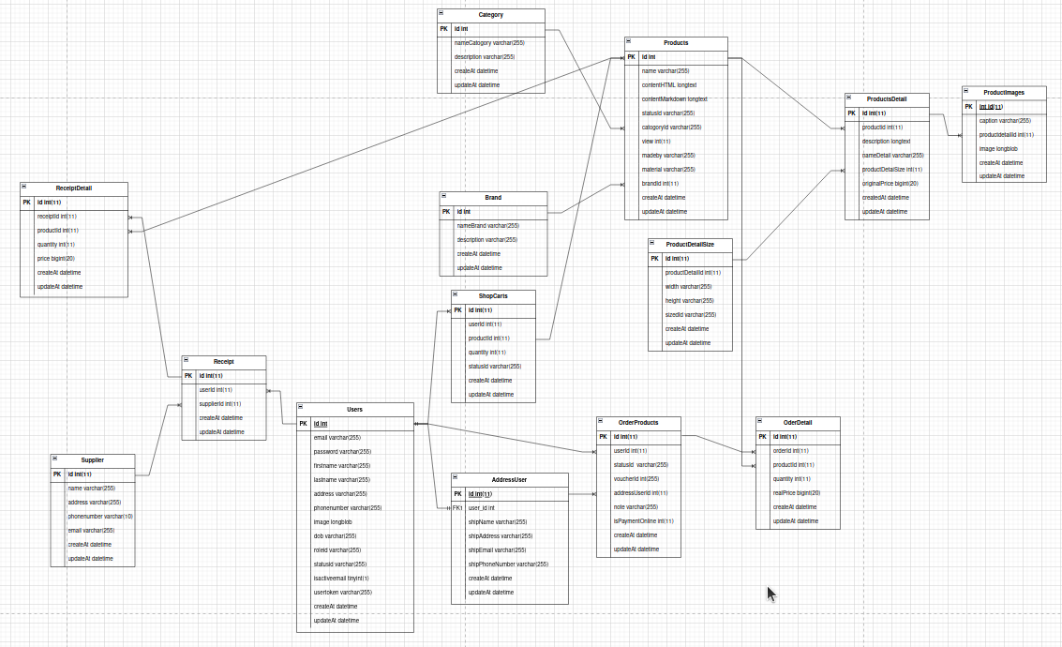

**Screen Shots**

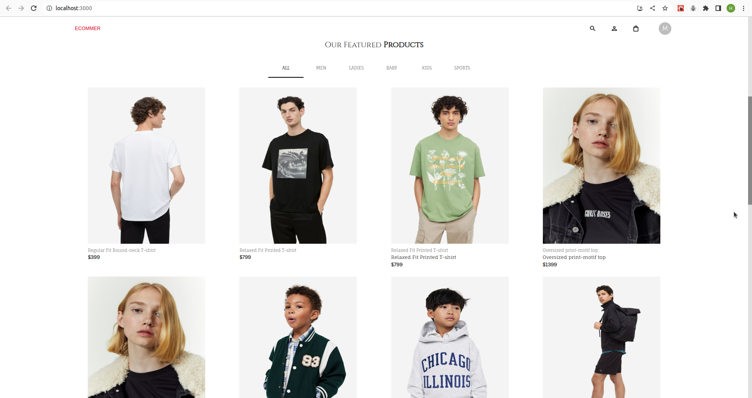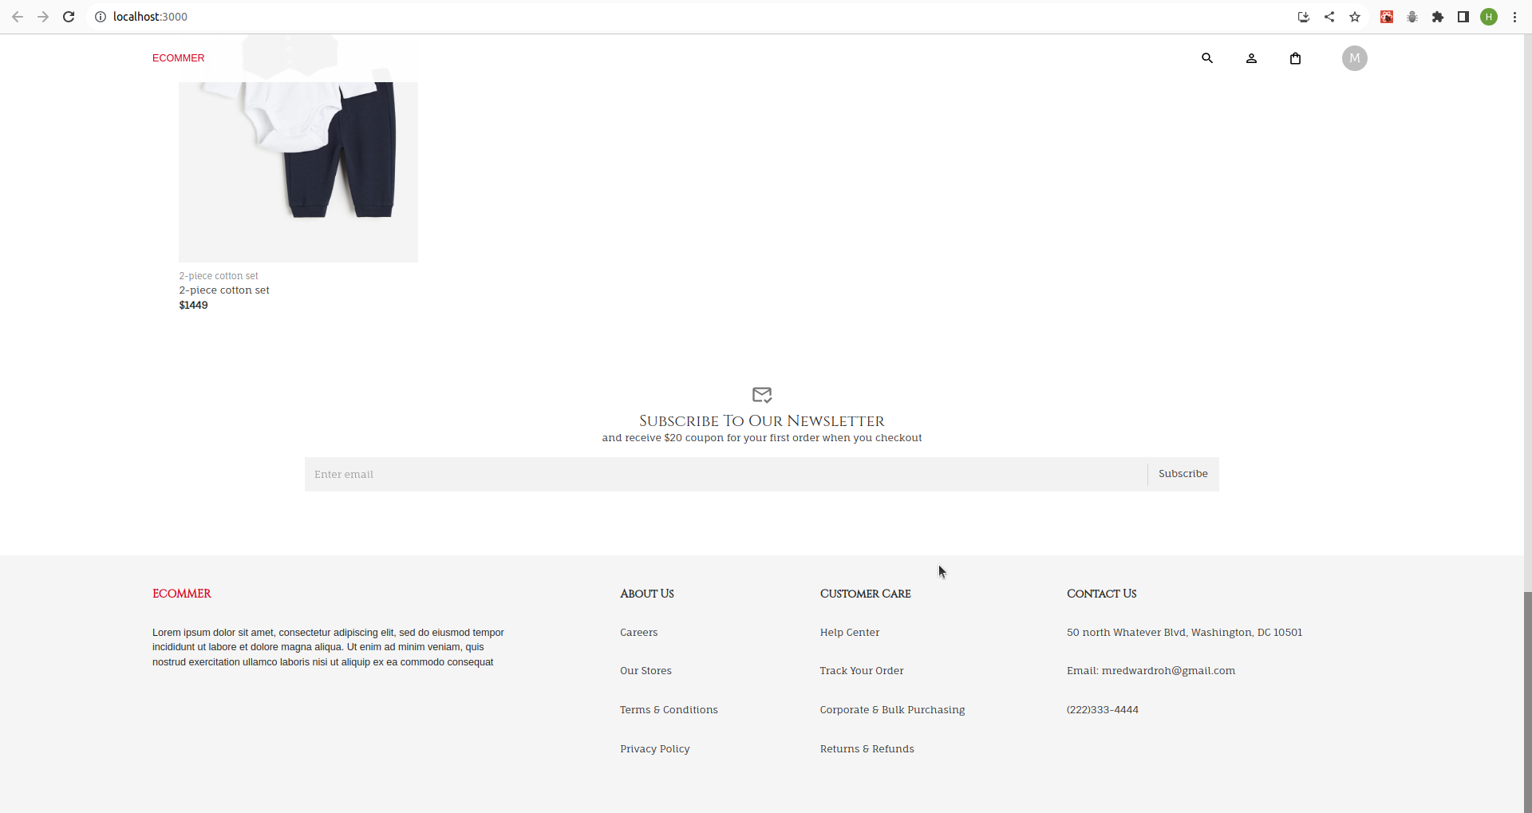

Fig. 4

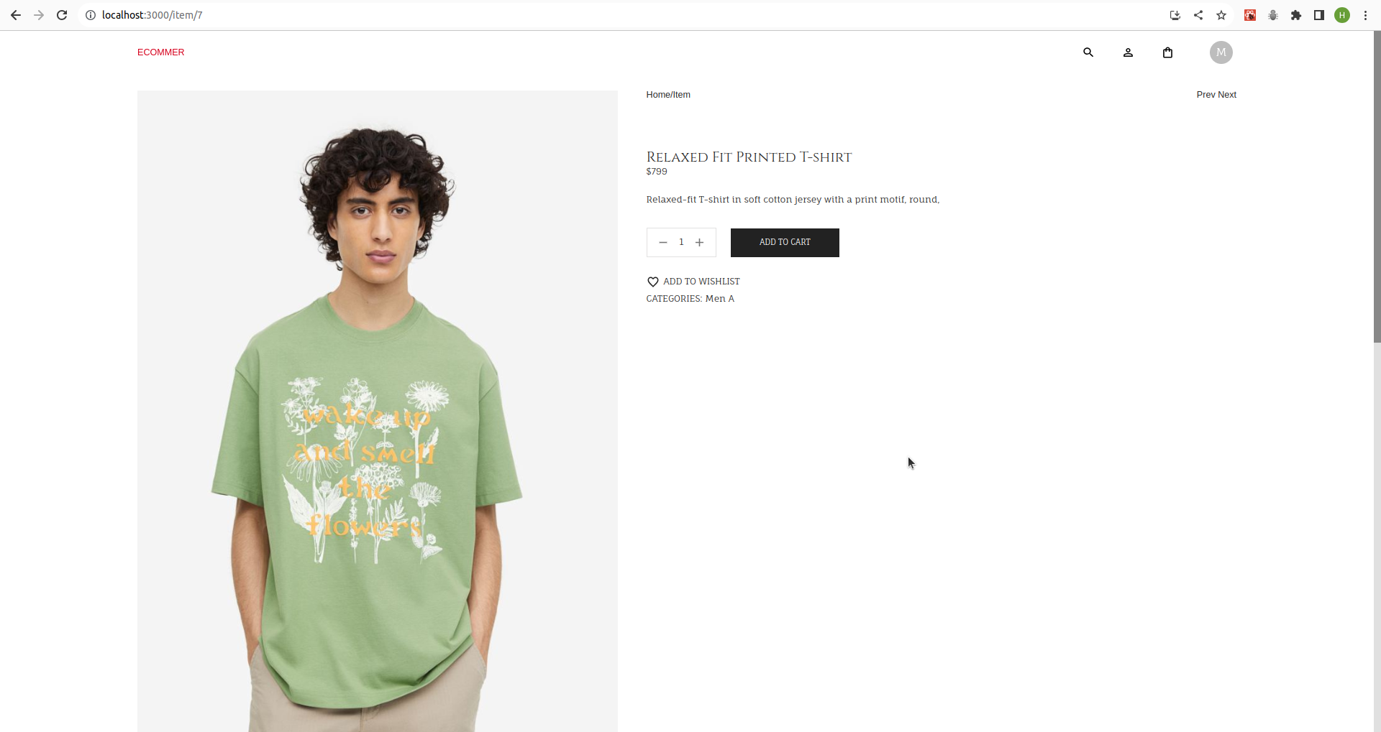

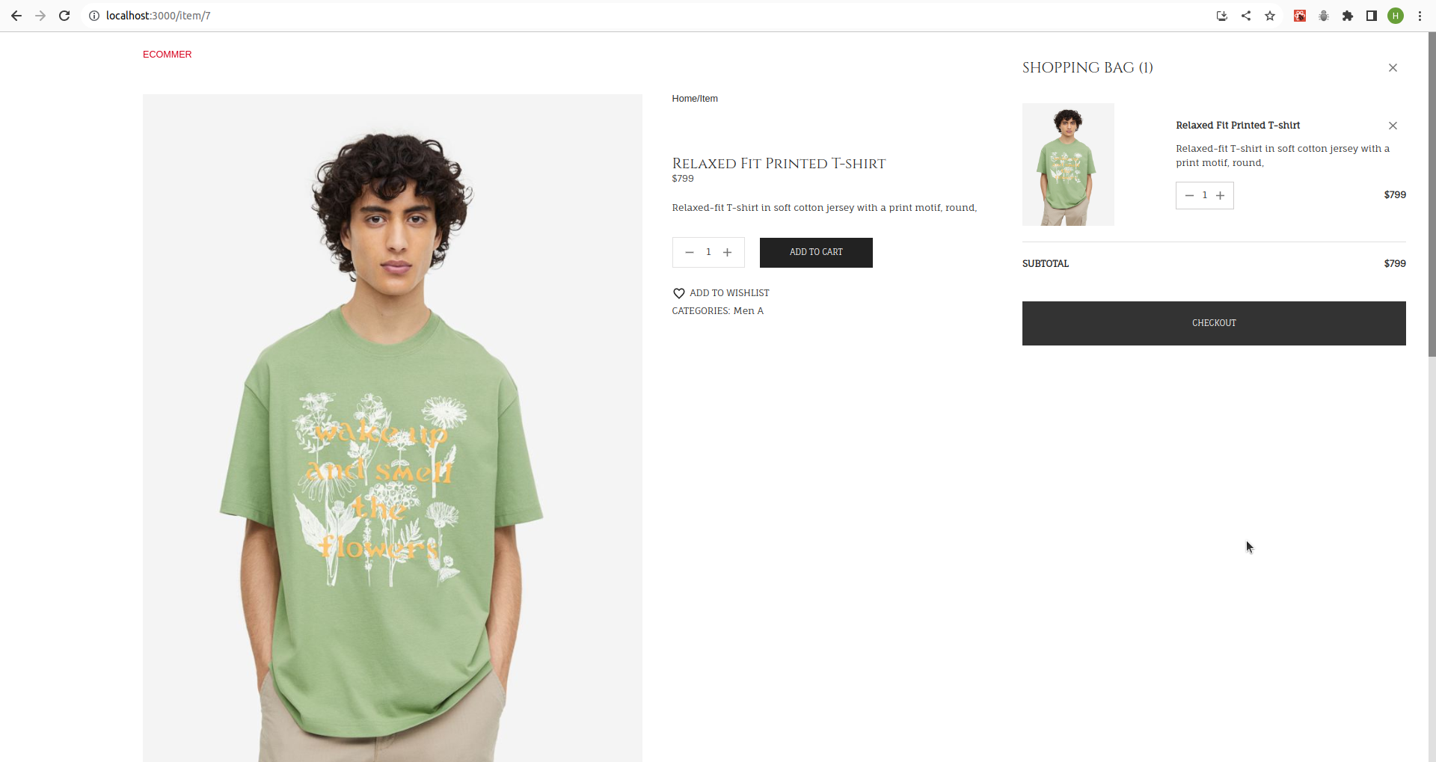

Fig. 5

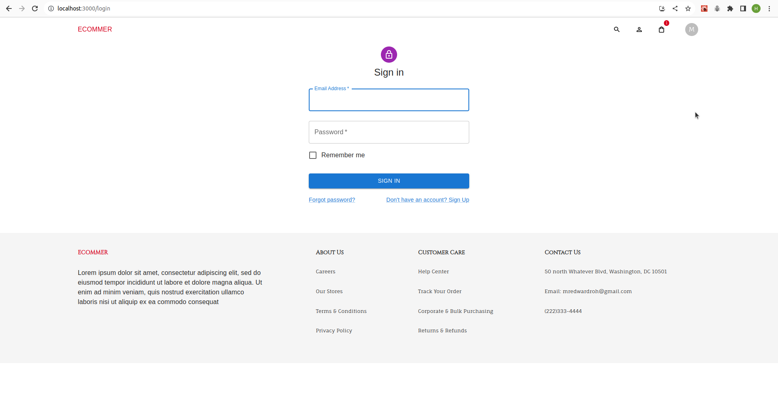

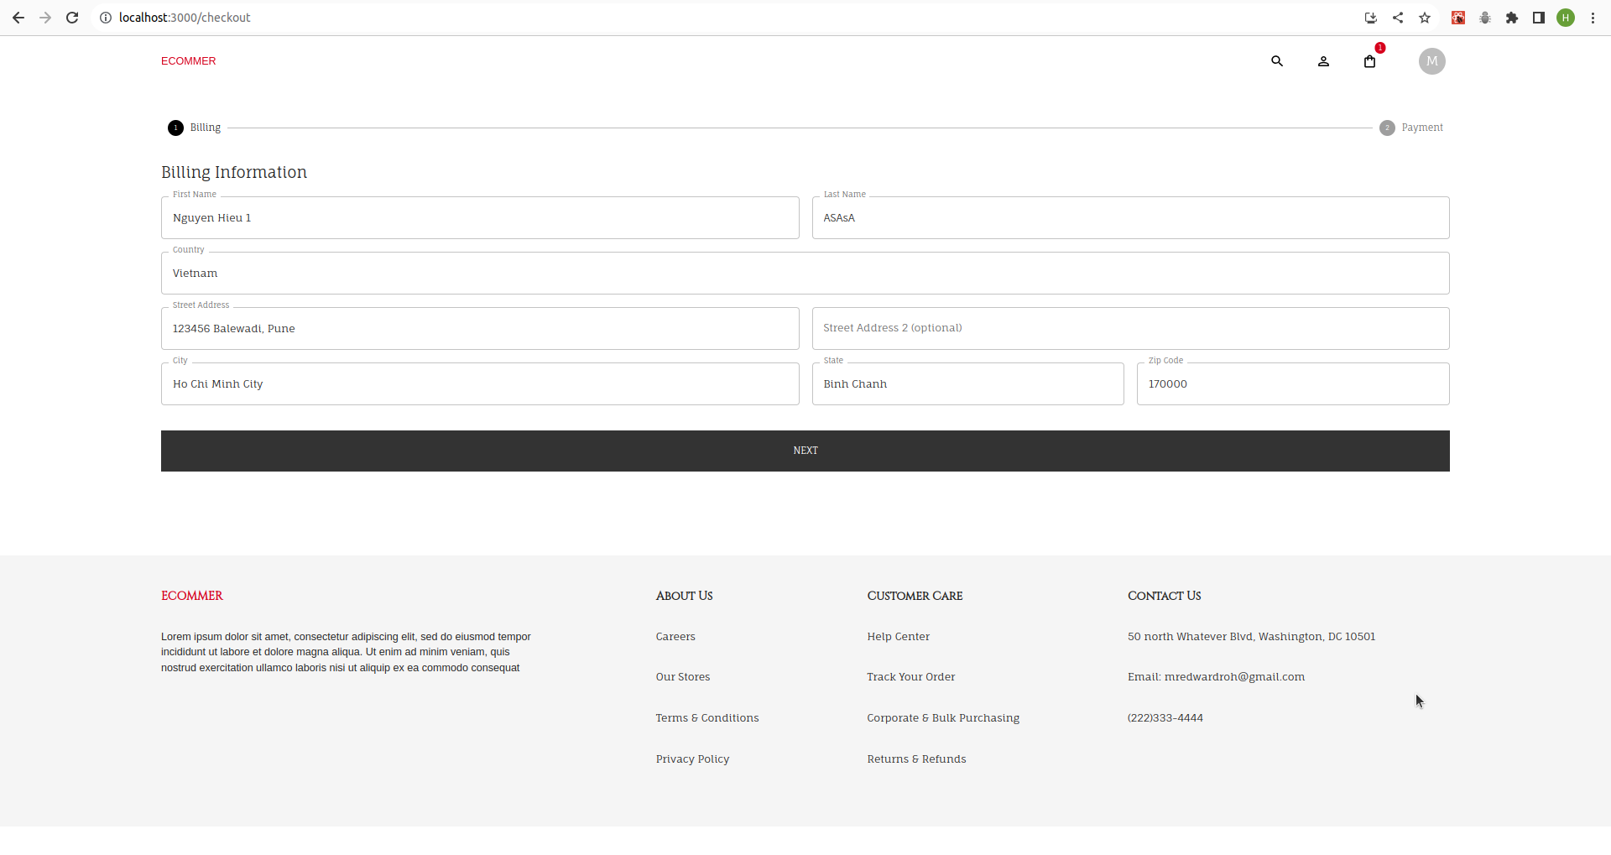Fig. 6

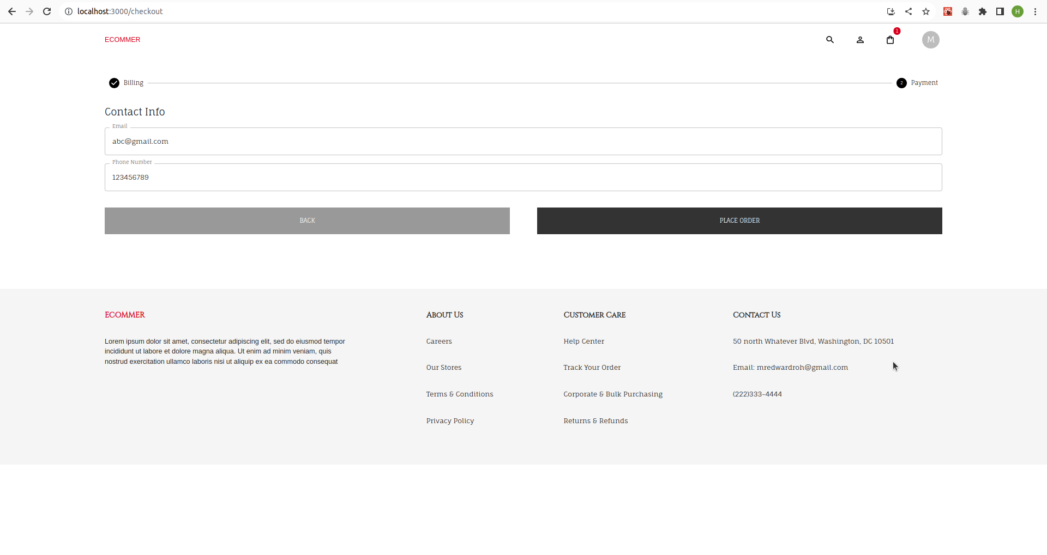Fig. 7

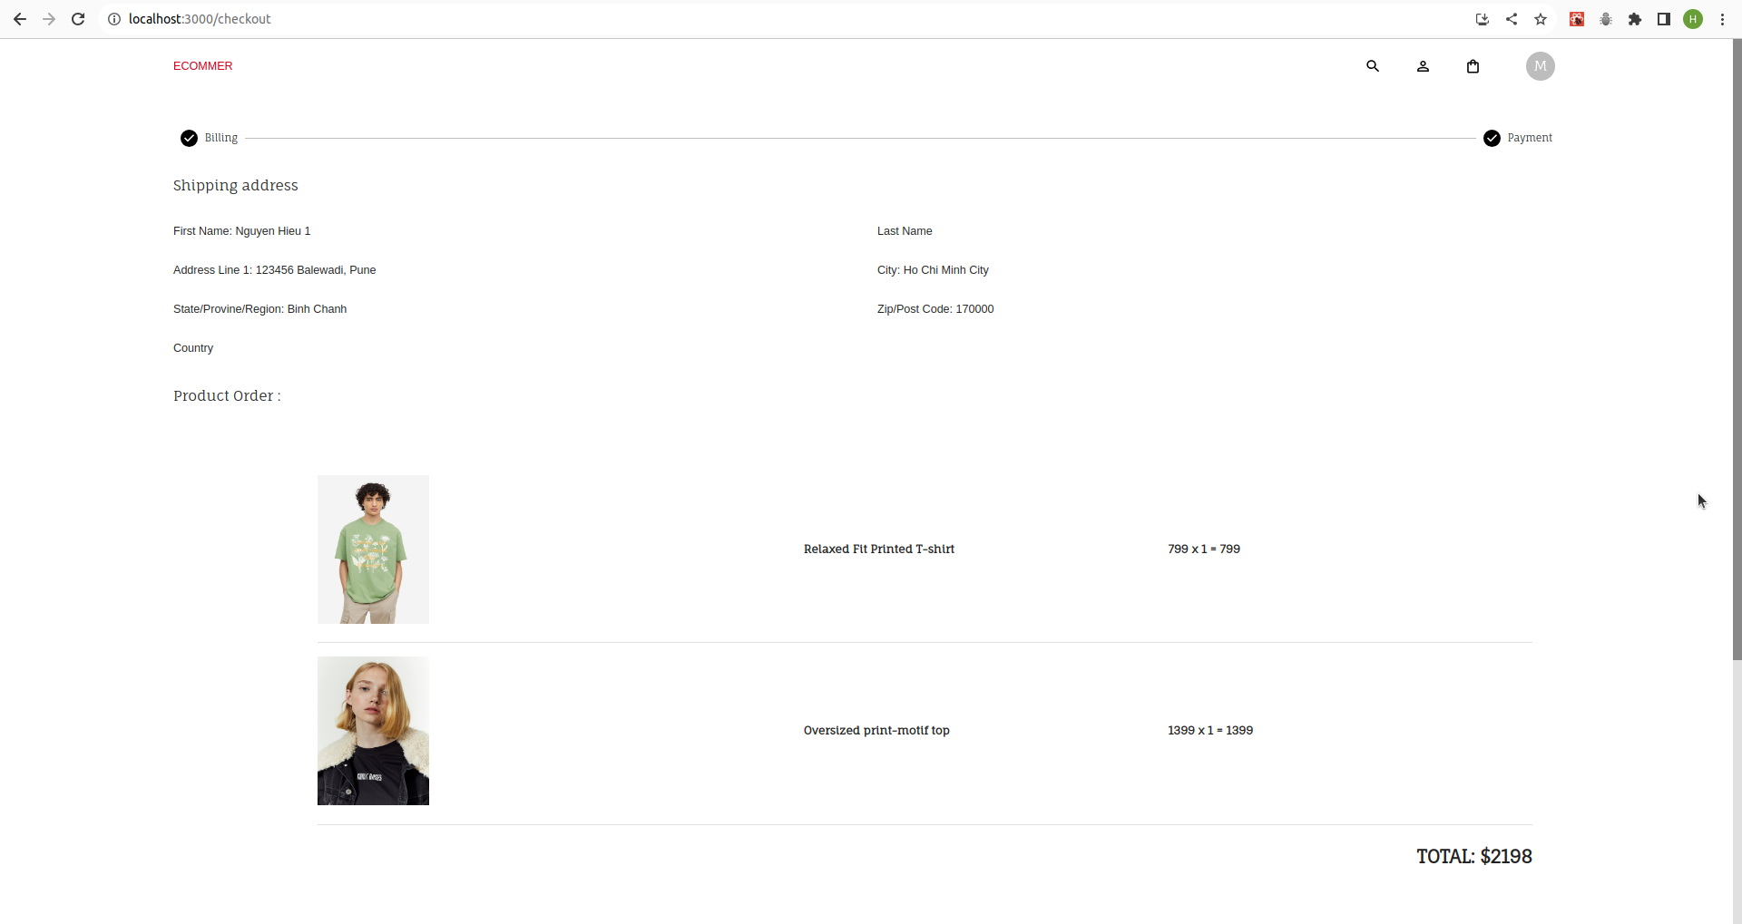Fig. 8

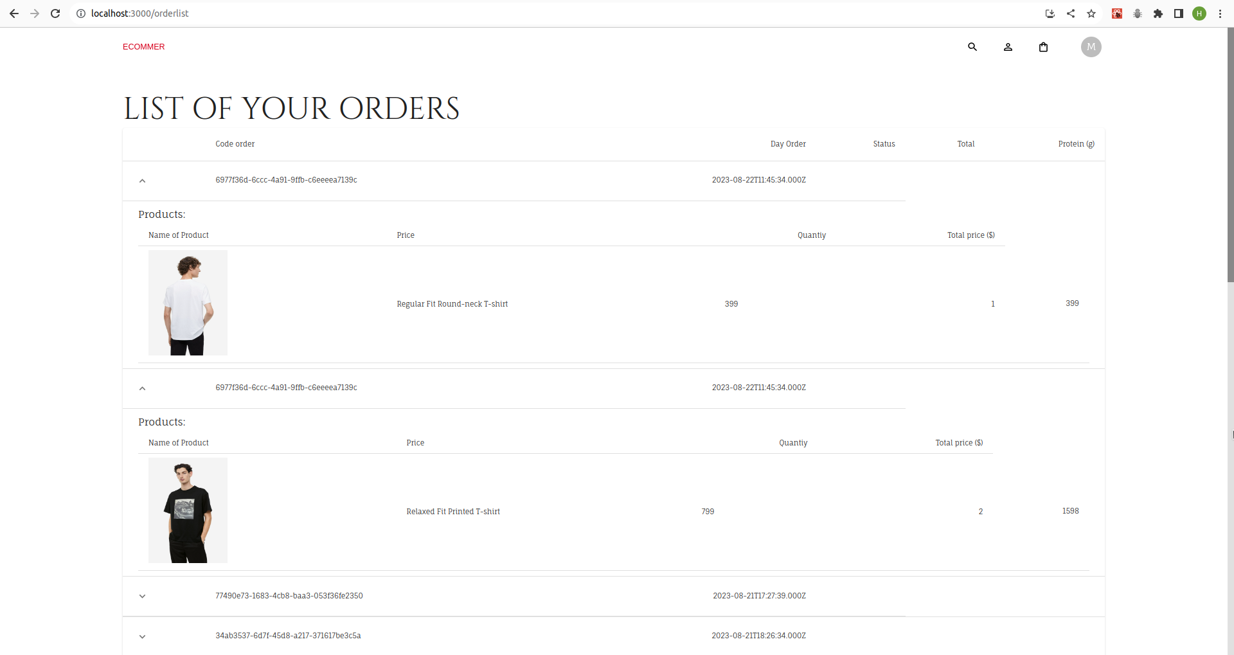Fig. 9

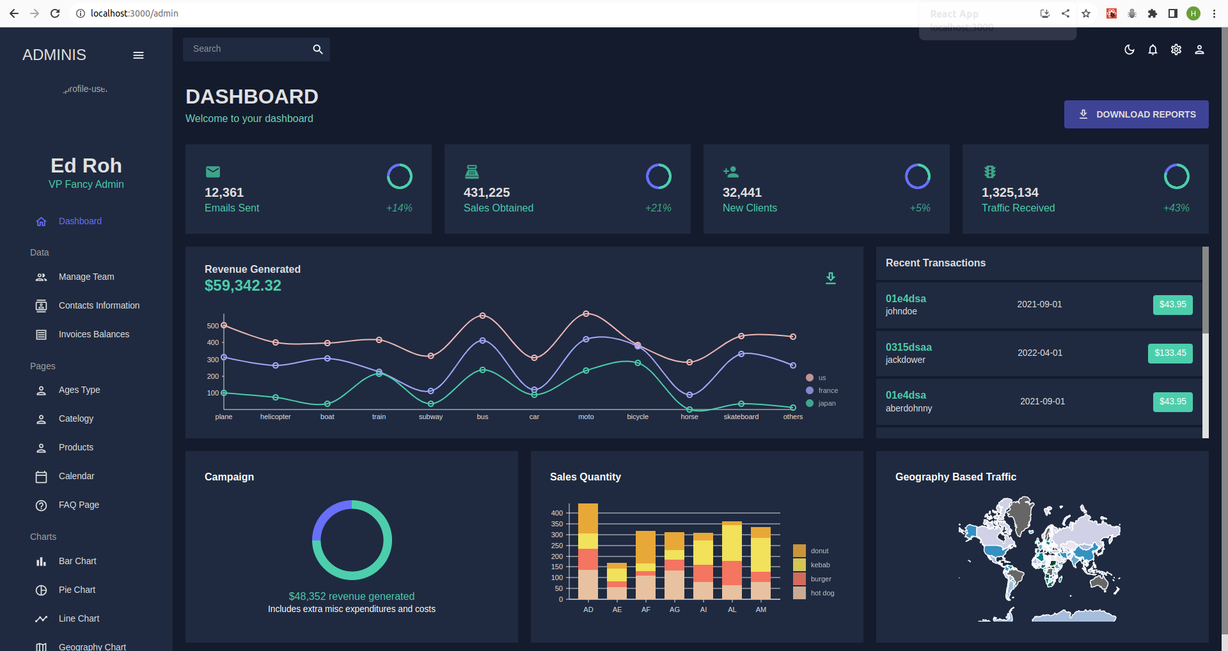

Fig. 10

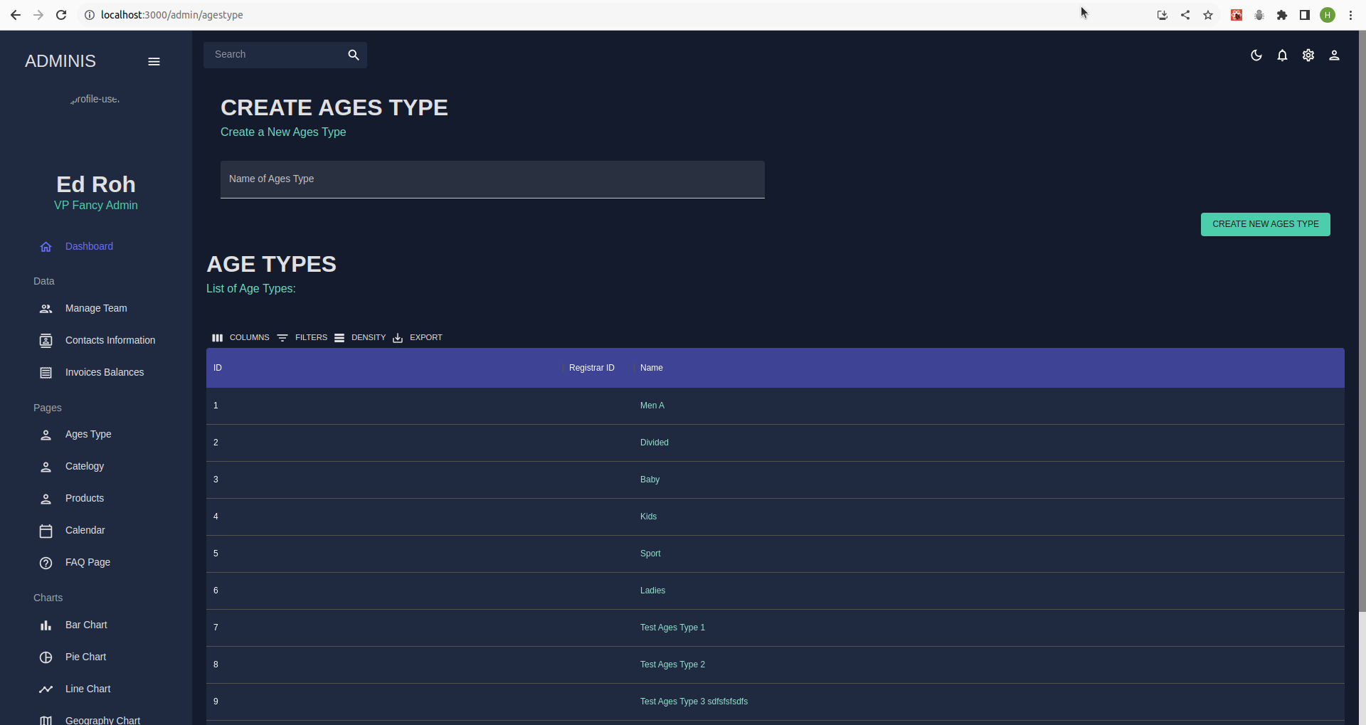

Fig. 11

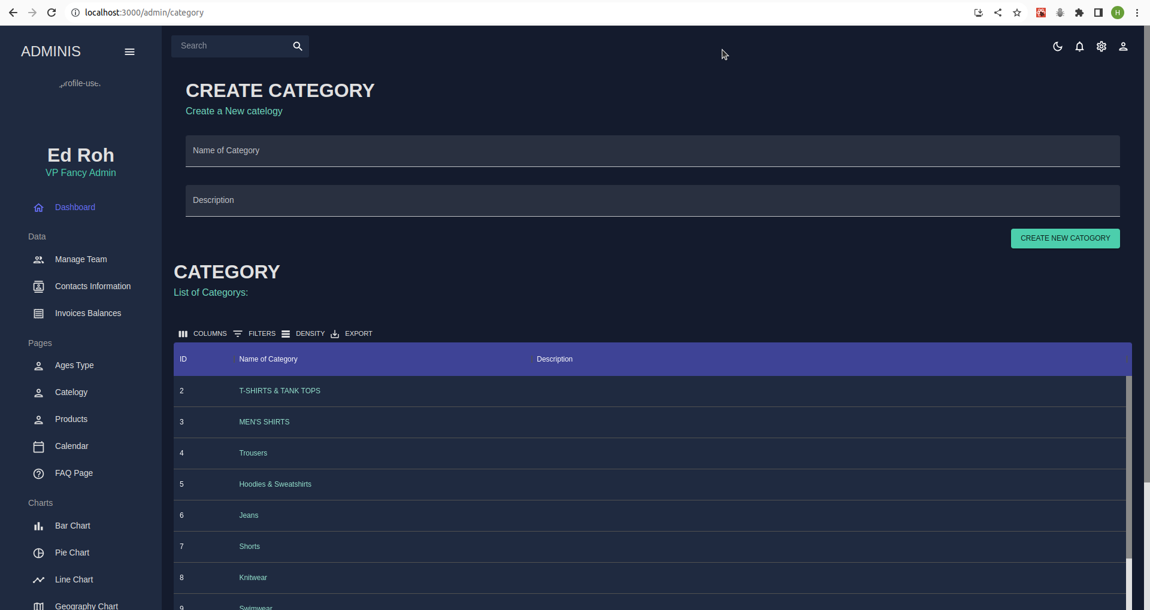

Fig. 12

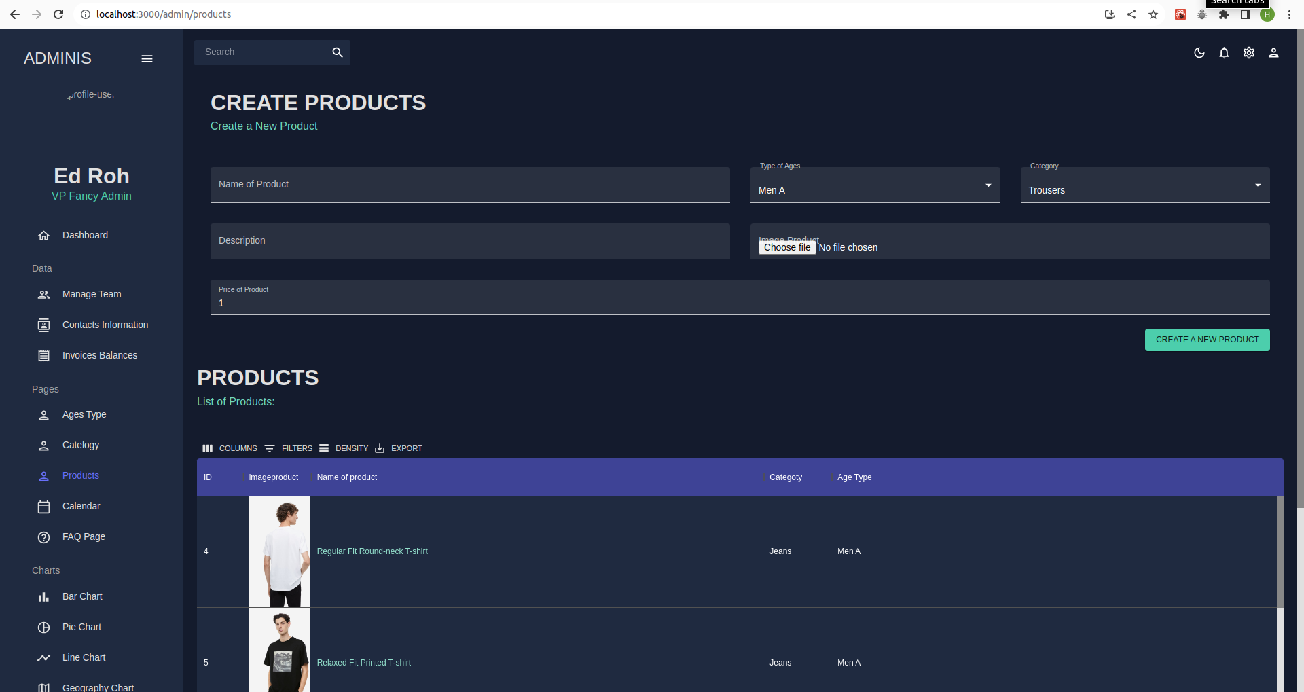

Fig. 13

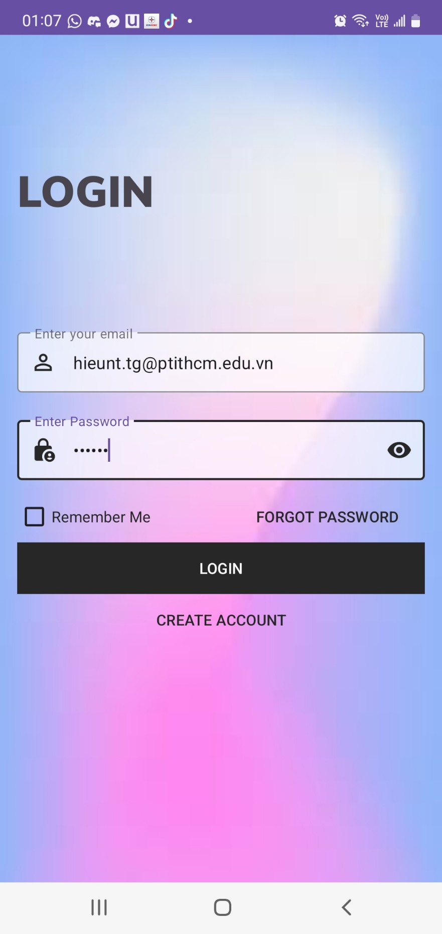

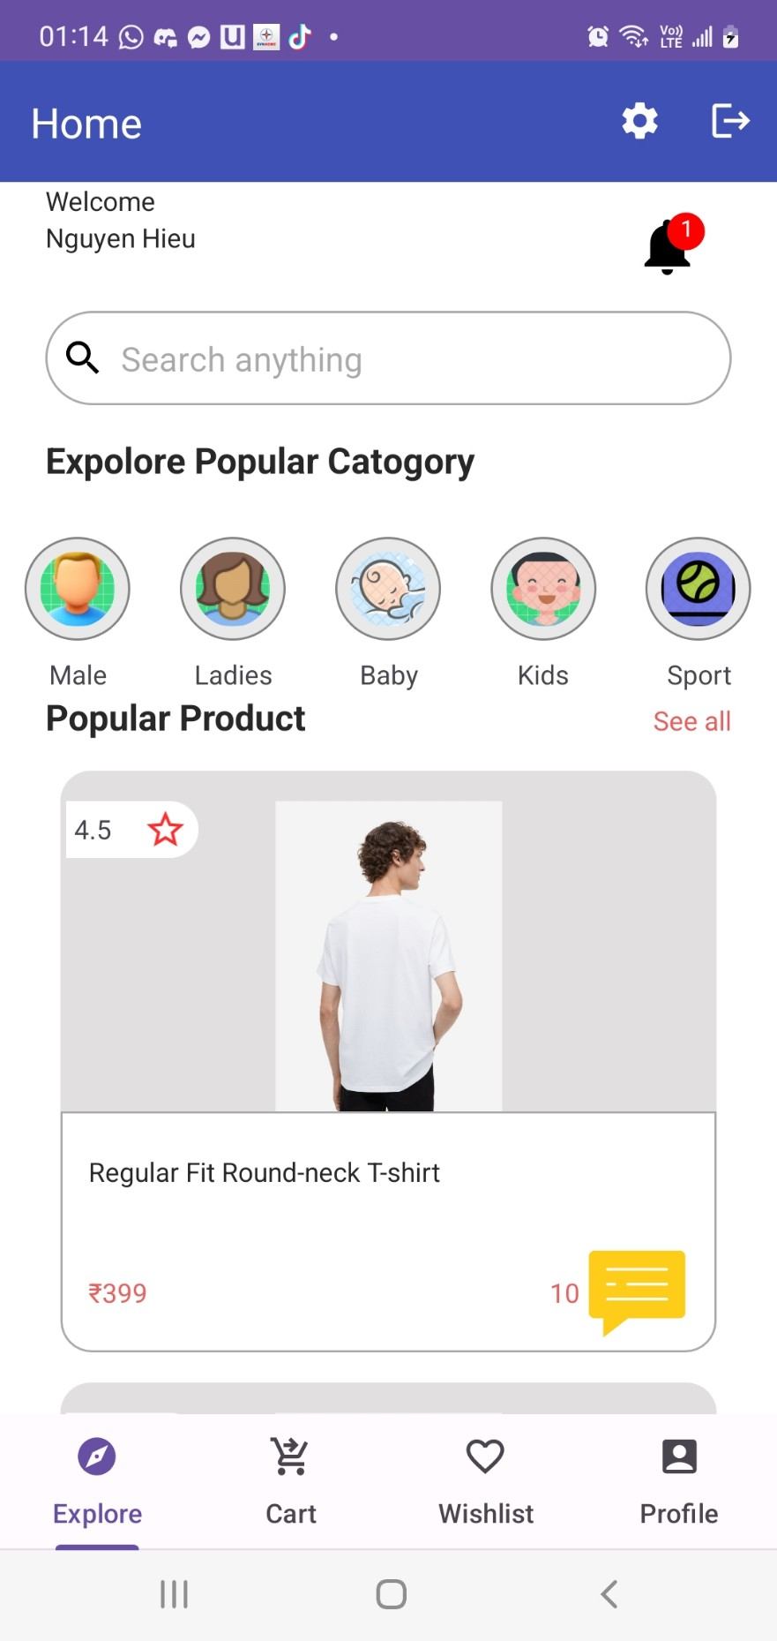

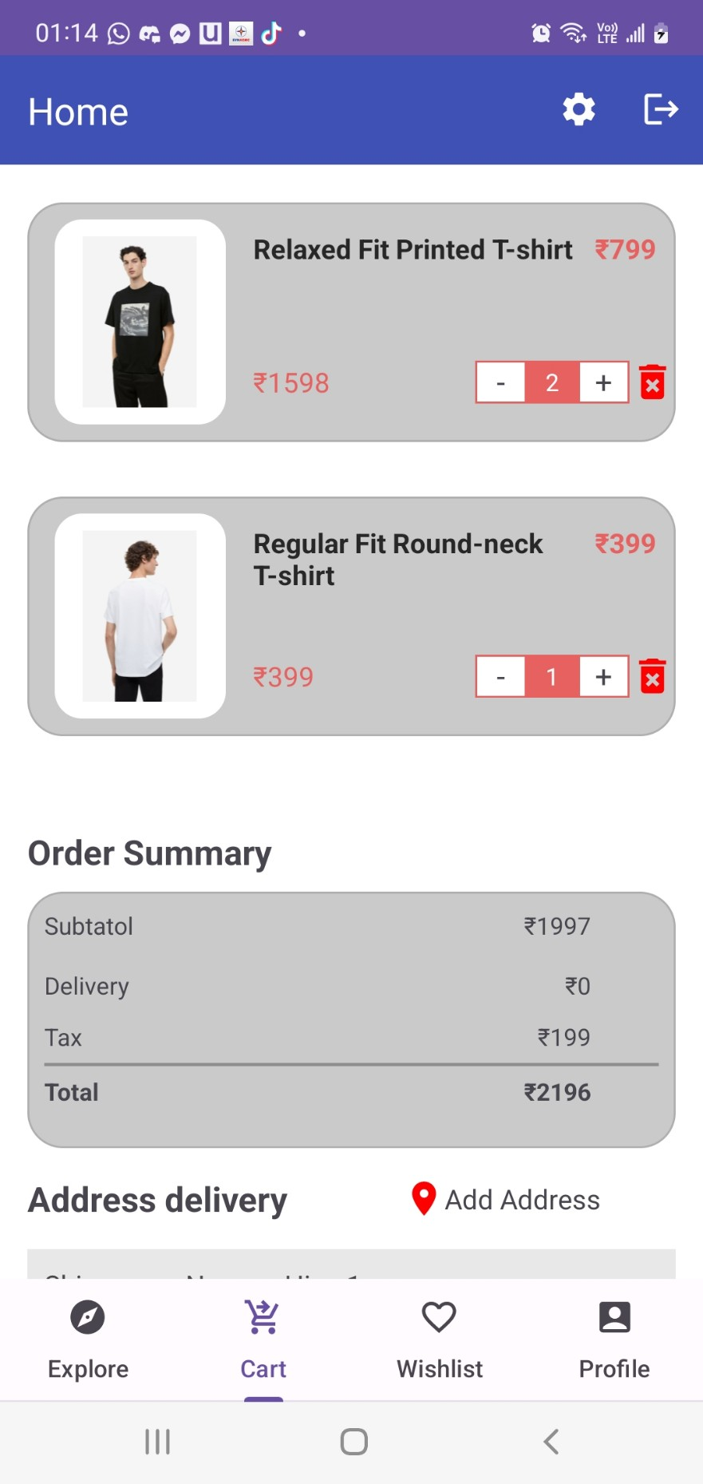

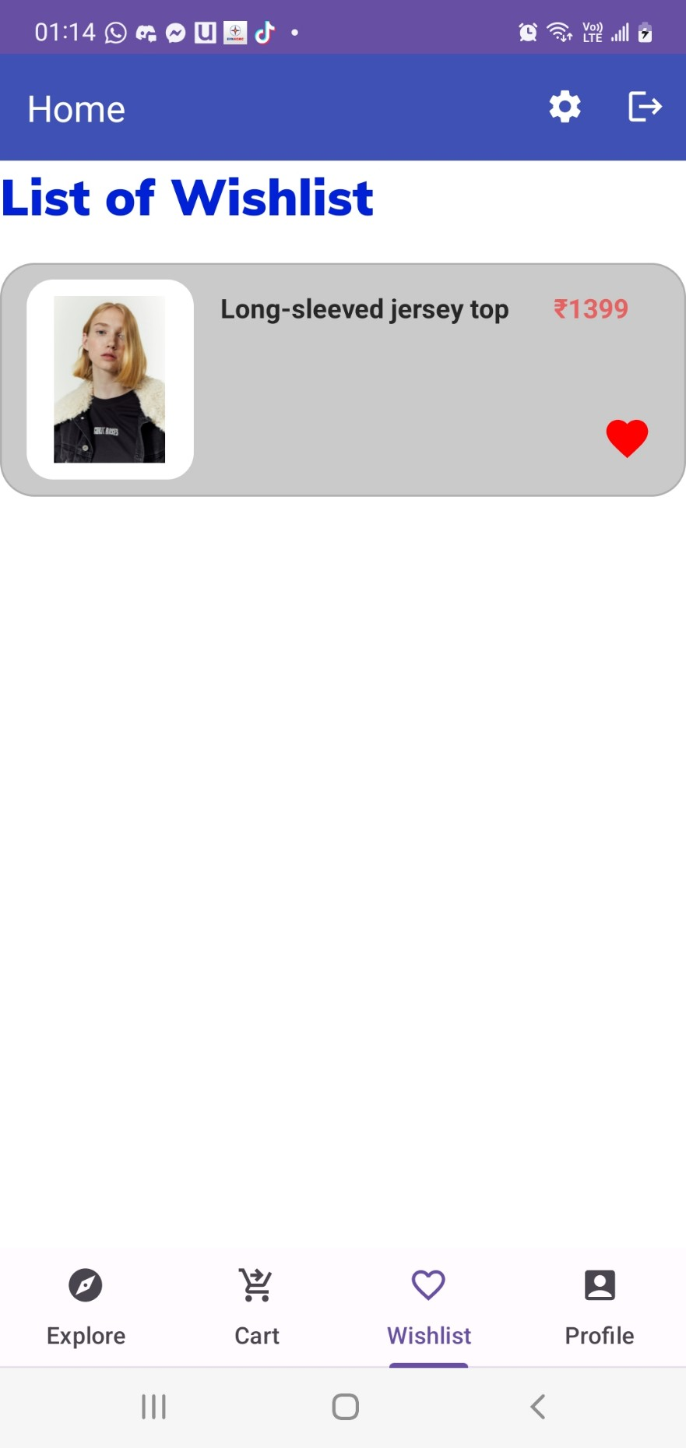

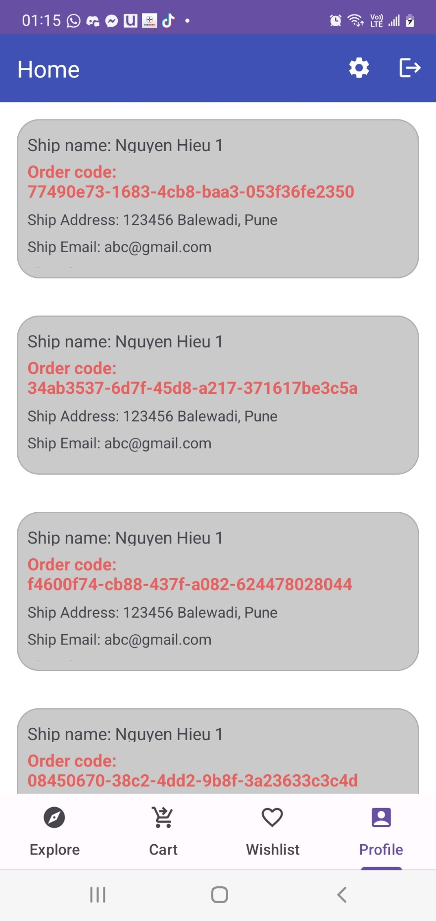

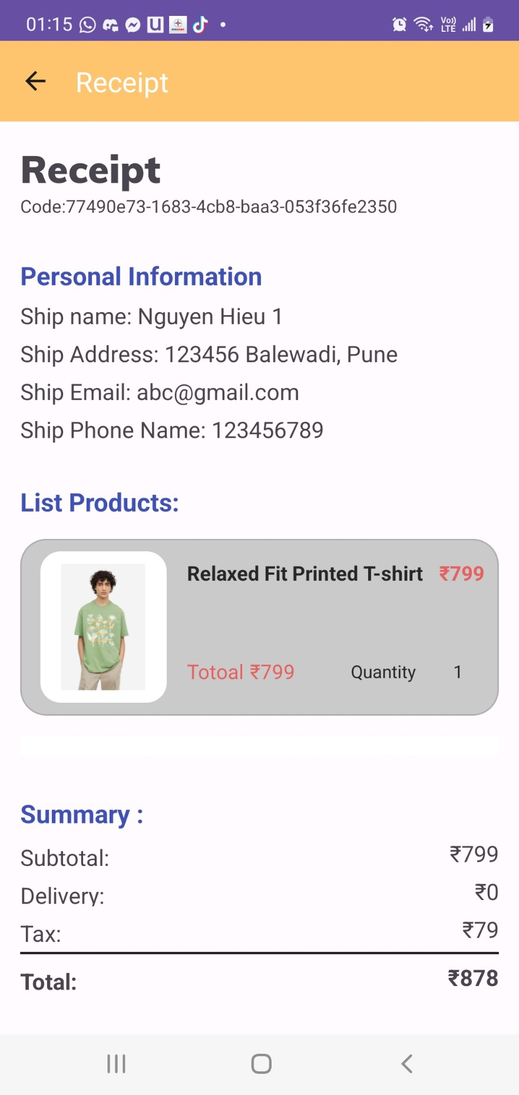

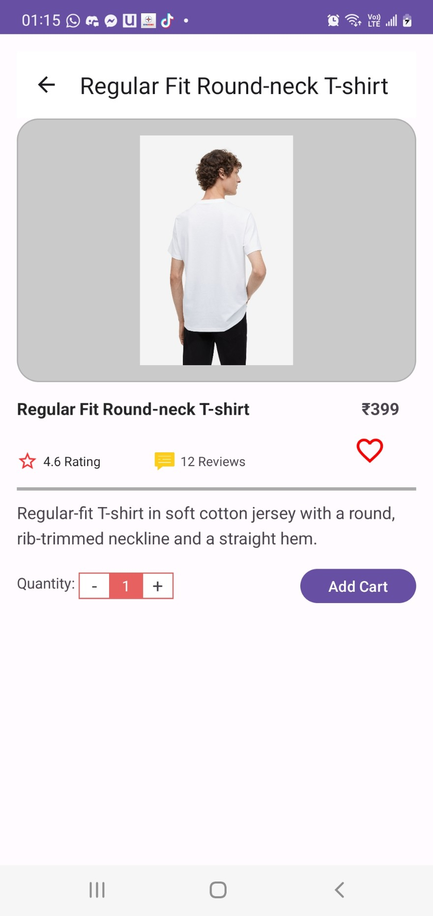

**| Conclusion:**  Achievement Although development was a challenge, our project team has successfully created an online sales business application. Our whole team learned:

* Learn the business related to the sales website (Cart, order,)
* Learn the Restfull API model.
* Front end: Html, css, ReactJs, Redux
* Mobile: Andoid platform.
* Backend: Nodejs, ExpressJs.
* In particular, we have completed an online shopping project for both web and mobile app

**| Future Work** :

* Expand statistics with a variety of graphs and statistics.
* Integrate many credit cards and e-wallets for convenient payment.
* Handles the ability to save photos so that messages can be sent with photos and videos..

**| References:**

https://developer.android.com/get-started/

Introduce about ReactJs - https://react.dev/reference/react

Introduce about ExpressJS - https://expressjs.com/en/4x/api.html